**Driving Quiz Project**

**Software Project Management Plan**

**November 26th, 2019**

**Professor Broadwater**

**Developed by:**

**Joseph Strickler, Alex Walters,**

**Jamal Lodge, and Alvin Kim**

**Project Scope:**

The scope of this project is to be able to develop a product that helps drivig students prepare for their driving exam in the form of a quiz-game layout. This product must be able to have accounts, take quizzes, link accounts, display previous results, integrate social media, have the MVA/DOT be able to connect to the database, and accept donations. We must accomplish all these goals in order to have a final product worthy enough to our client.

**Purpose:**

The purpose of this project is to help increase the amount of driving students pass rates by using this final product. This project should help students study for their live driving exam. This project also allows parents to see how ready their kids are for their real driving test from how much knowledge they know of the road. The MVA/DOT are counting on us to develop a tool they can use and monitor upcoming drivers.

**Software Process:**

For this project our process that we are going to use would be breaking this project into different tasks. For example, out of the 4 people on this team, 2 of them will work on the backend of things, and the other 2 will work on the frontend of things. Every week we will meet together to talk about what has been completed, how we will integrate them together, and any complications we have encountered and try to resolve them. This will make the project seem not as complex and allow us to work on each piece instead of the entire thing as a whole.

**Table of Contents**

Part 1: Introduction

* 1. Executive Summary…………………………………………………………………………….4
  2. Project Deliverables…………………………………………………………………………….4
  3. Evolution of the SPMP…………………………………………………………………………4
  4. Reference Materials……………………………………………………………………………4
  5. Definitions & Acronyms………………………………………………………………………5

Part 2: Project Organization

2.1 Process Model……………………………………………………………………………………5

2.2 Organizational Structure…………………………………………………………………….6

2.3 Organizational Structure……………………………………………………………………6

2.4 Project Responsibilities……………………………………………………………………..6

Part 3: Managerial Process

3.1 Management Objectives and Priorities………………………………………………..6

3.2 Assumptions, Dependencies, and Constraints…………………………………….6

3.3 Risk Management……………………………………………………………………………..7

Contractual Risks………………………………………………………………………...7

Size of Project……………………………………………………………………………..7

Client Acceptance……………………………………………………………………….7

3.4 Staffing Plan……………………………………………………………………………………7

3.5 Monitoring and Controlling Mechanisms………………………………………….7

Part 4: Technical Process

4.1Methods, Tools, and Techniques……………………………………………………….7

4.2 Software Documentation………………………………………………………………..7-8

4.3 Project Support Functions………………………………………………………………8

Part 5: Description of Work Packages

5.1 Work Breakdown Structure……………………………………………………………8

Gantt Charts……………………………………………………………………………………………………10

**Part 1: Introduction**

**1.1 Executive Summary**

The US Dept. of Transportation has assigned our team to accomplish a way that users can help study for their driving exams through the use of an online portal. The goal of this is for users to be able to access our website and either sign up or just anonymously practice. Our website is going to offer the users the ability to take quizzes to help them learn real life scenarios while driving. The game will generate reports of scores for all past completed quizzes and be able to compare them. The DOT and MVA will have the ability to access specific records to see users progress. The users parents or guardians will have the same capability. This game will give the users the option to connect with social media to advertise their scores as well. The final part will be that our website will allow outside sources to donate or advertise on our site to help support our mission. The final product will help improve driving test scores on newly upcoming drivers.

**1.2 Project Deliverables**

* + - Requirements – Due 9/10
    - Use cases & Sequence diagrams – Due 9/10
    - High level architecture, Class diagrams, and interface specifications – Due 9/17
    - Software Project Management Plan (SPMP) – Due 9/24
    - Organizational structure – Due 9/24
    - Work breakdown structure (WBS) – Due 9/24
    - Test Skeleton – Due 10/01
    - Repo Setup – Due 9/20
    - Mid Semester Presentation – Due 10/15
    - Code Review 1 – Due 10/15, Code Review 2 – Due 10/22, Code Reivew 3 – Due 10/29
    - Final Presentation – Due 12/3

**1.3 Evolution of the SPMP**

Since we are in the beginning stages of the project planning there will most likely be some changes. To ensure these changes do not mess up our project schedule will we allow time after each deliverable to ensure the full completion of them. If there are any changes, we will go back and edit them before continuing onto the next piece.

**1.4 Reference Materials**

Domain: Name.com

Web Host: HostGator.com

Website Builder: Wordpress

Plugins: Adminimize, HDQuiz, HDQuiz Custom, Gitium, Paypal Donations, Profile builder, Really simple SSL, Remove Dashboard Access, WP Data access.

.

**1.5 Definitions & Acronyms**

**Part 2: Project Organization**

**2.1 Process Model**

The project was assigned on September 2019 and is to be completed by the end of the semester in December 2019. Major milestones for our project is our weekly updated deliverables and group presentation on December 17,2019.

The process model or plan we used to begin our project was based on using wordpress and assigning team members different responsibilities. Our team is made up of four team members splitting two for frontend development and two for backend development. Within the frontend and backend teams, we then allocate what is to be expected and documented by each team member. The individual approved documents produced by the teams are considered work products and are part of the software documentation. Everything is to be documented in the repository or through wordpress. Once a week both frontend and backend teams come together to explain any conflicts, new ideas, or changes to our project. The structure and specific responsibilities of our development team follows.

**2.2 Organizational Structure**

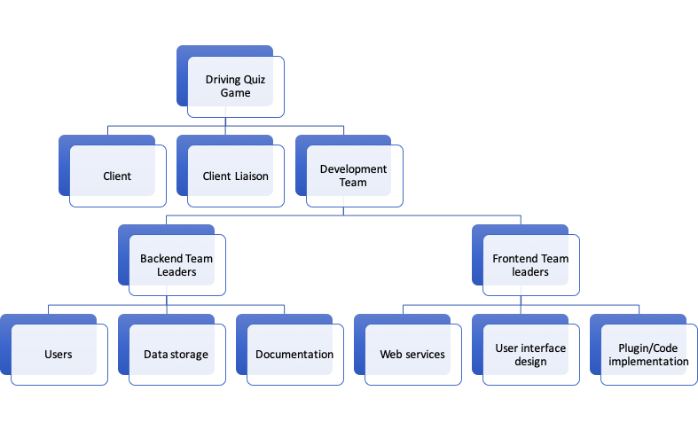

**2.3 Organizational Interfaces**

Team leaders throughout each and every phase will be responsible for coordinating team meetings, contributing to the repository, communicating, and updating deliverables. The documentation for each respective task will be done by the individual who it has been assigned to.

**2.4 Project Responsibilities**

The main functions and activities of the project are:

Creating a database- Alex will be in charge of setting up the database for our website so we can store all of the questions for the driving quiz

Structure of quiz - Joey will be in charge of setting up the quiz layout and the basic functions that the quiz will be able to accomplish

Account setup - Alvin will be in charge of setting up the account registration and log in features for our website

User interface- Jamal will be in charge of setting up the user interface for our website

Creating quiz questions - This will be handled by everyone in the group, since there will be a good amount of questions we will each individually add questions to a list that we will add into our database

**Part 3: Managerial Process**

**3.1 Management Objectives and Priorities**

Our goal is to ensure we are completing each requirement as we move through our project process. We have a set schedule time that we should be completing each task by to maintain with our budget amount. Our team manager will keep up with each individuals responsibility to maintain our schedule.

**3.2 Assumptions, Dependencies and Constraints**

The project must meet the requirements of the MVA and DOT driving exam requirements. We will ensure that our questions with in our quiz are credible questions that would be encountered or asked in a physical driving exam. We will not make up random questions that have nothing to do with a driving test.

**3.3 Risk Management**

**Contractual Risks**

This could be a big potential risk because if our client does not have the appropriate amount of money to fund the project then we could get stuck in the middle of progress with no incentive to move forward. The other part of this would be if we were to blow the budget our client has offered us, the client may not want to put forth more money for it.

**Size of the Project**

The risk of the project being too large will not be a problem. With our team we will break this project into parts and approach each part together and efficiently. The only risk that could become of this would be if the client wants to add more requirements to it later down the road. This could make the size become too large for us to hit the project deadline.

**Client Acceptance**

If our client does not like our prototype then we will have to try to make some changes to it to establish a different prototype. The way we will try to avoid this would be keeping in contact with the client. Even though we will not talk to them about every single detail, we will ensure that when we have questions we will make sure we ask our client so we are not moving in any wrong directions.

**3.4 Monitoring and Controlling Mechanisms**

Our team will communicate almost everyday with updates or details on what we are completing at the time. We will also report to our project manager of updates on completion status.

**3.5 Staffing Plan**

Our staff will be our team currently. We will have no budging money to be able to hire any external contractors. Our team will be comprised of 4 team members.

Part 4: Technical Process

**4.1 Methods, Tools, and Techniques**

Some of the techniques we will use for our project will be breaking it up into pieces. Each member of our group has a specific task that they are assigned. This way we will be able to distribute the work-load and then integrate the pieces together after checking each individuals work. Even though we each have individual tasks, since we are reporting back as a group it allows us all to look over each piece and see where any improvements could be made.

**4.2 Software Documentation**

Each team member will complete parts of their task and post it on Github. This way even when a team member makes updates every other member will see them. Also Github will forbit some other users to edit the same thing at the same time. Along with this we will keep track of all the individual tasks that we complete by checking them off the list. This way we can move to another task.

**4.3 Project Support Functions**

**Part 5: Description of Work Packages**

**5.1 Work Breakdown Structure**

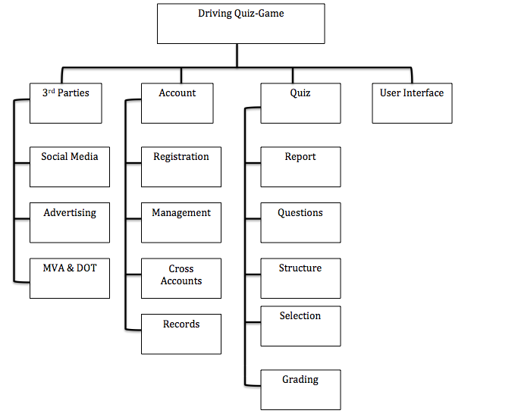

Gantt Chart

